WEB APPLICATION DEVELOPMENT LAB

TASK LAB-DAY 2

05-12-2024

Sai Ganesh Eswaraprasad

HU22CSEN0100287

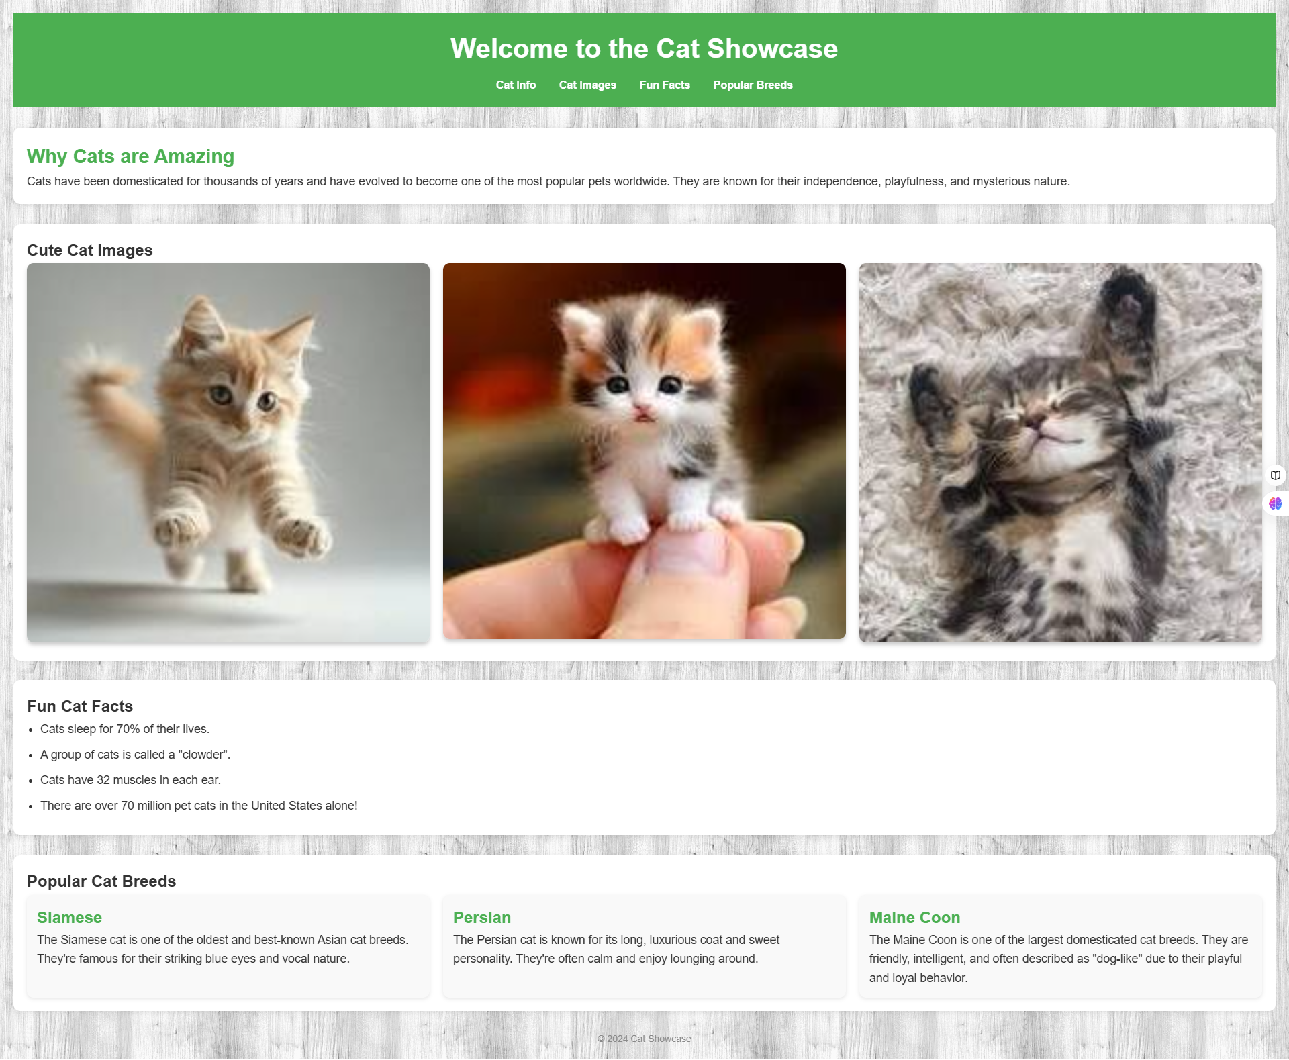

HTML Code:

<!DOCTYPE html>

<html lang="en">

<head>

    <title>Cat Showcase</title>

    <link rel="stylesheet" href="task2.css">

</head>

<body>

    <header>

        <h1>Welcome to the Cat Showcase</h1>

        <nav>

            <ul>

                <li><a href="https://www.google.com/search?q=cats">Cat Info</a></li>

                <li><a href="https://www.google.com/search?udm=2&q=cats">Cat Images</a></li>

                <li><a href="https://www.google.com/search?q=cats+fun+facts">Fun Facts</a></li>

                <li><a href="https://www.google.com/search?q=cats+breeds">Popular Breeds</a></li>

            </ul>

        </nav>

    </header>

    <section id="cat-info">

        <h2>Why Cats are Amazing</h2>

        <p>Cats have been domesticated for thousands of years and have evolved to become one of the most popular pets worldwide. They are known for their independence, playfulness, and mysterious nature.</p>

    </section>

    <section id="cat-images">

        <h2>Cute Cat Images</h2>

        <div class="cat-images-gallery">

            <div class="cat-image">

                <img src="download.jpg" alt="Cute Kitten 1">

            </div>

            <div class="cat-image">

                <img src="download (1).jpg" alt="Cute Kitten 2">

            </div>

            <div class="cat-image">

                <img src="download (2).jpg" alt="Cute Kitten 3">

            </div>

        </div>

    </section>

    <section id="fun-facts">

        <h2>Fun Cat Facts</h2>

        <ul>

            <li>Cats sleep for 70% of their lives.</li>

            <li>A group of cats is called a "clowder".</li>

            <li>Cats have 32 muscles in each ear.</li>

            <li>There are over 70 million pet cats in the United States alone!</li>

        </ul>

    </section>

    <section id="cat-breeds">

        <h2>Popular Cat Breeds</h2>

        <div class="breed-list">

            <div class="breed-item">

                <h3>Siamese</h3>

                <p>The Siamese cat is one of the oldest and best-known Asian cat breeds. They're famous for their striking blue eyes and vocal nature.</p>

            </div>

            <div class="breed-item">

                <h3>Persian</h3>

                <p>The Persian cat is known for its long, luxurious coat and sweet personality. They're often calm and enjoy lounging around.</p>

            </div>

            <div class="breed-item">

                <h3>Maine Coon</h3>

                <p>The Maine Coon is one of the largest domesticated cat breeds. They are friendly, intelligent, and often described as "dog-like" due to their playful and loyal behavior.</p>

            </div>

        </div>

    </section>

    <footer>

        <p>&copy; 2024 Cat Showcase</p>

    </footer>

</body>

</html>

CSS Code:

/\* Reset basic styles \*/

\* {

    margin: 0;

    padding: 0;

    box-sizing: border-box;

}

/\* Basic layout \*/

body {

    font-family: 'Arial', sans-serif;

    line-height: 1.6;

    background-color: #fafafa;

    color: #333;

    padding: 20px;

    background-image: url('https://www.transparenttextures.com/patterns/purty-wood.png');

}

/\* Header Section \*/

header {

    background-color: #4CAF50;

    color: #fff;

    padding: 20px;

    text-align: center;

}

header h1 {

    margin-bottom: 10px;

    font-size: 2.5rem;

}

nav ul {

    list-style-type: none;

    padding: 0;

}

nav ul li {

    display: inline;

    margin: 0 15px;

}

nav ul li a {

    color: #fff;

    text-decoration: none;

    font-weight: bold;

}

nav ul li a:hover {

    text-decoration: underline;

}

/\* Cat Info Section \*/

#cat-info {

    margin-top: 30px;

    background-color: #fff;

    padding: 20px;

    border-radius: 10px;

    box-shadow: 0 2px 10px rgba(0, 0, 0, 0.1);

}

#cat-info h2 {

    font-size: 1.8rem;

    color: #4CAF50;

}

#cat-info p {

    font-size: 1.1rem;

}

/\* Cat Images Gallery \*/

#cat-images {

    margin-top: 30px;

    background-color: #fff;

    padding: 20px;

    border-radius: 10px;

    box-shadow: 0 2px 10px rgba(0, 0, 0, 0.1);

}

.cat-images-gallery {

    display: grid;

    grid-template-columns: repeat(3, 1fr);

    gap: 20px;

}

.cat-image img {

    width: 100%;

    border-radius: 10px;

    box-shadow: 0 4px 6px rgba(0, 0, 0, 0.2);

}

@media (max-width: 768px) {

    .cat-images-gallery {

        grid-template-columns: 1fr 1fr;

    }

}

@media (max-width: 480px) {

    .cat-images-gallery {

        grid-template-columns: 1fr;

    }

}

/\* Fun Facts Section \*/

#fun-facts {

    margin-top: 30px;

    background-color: #fff;

    padding: 20px;

    border-radius: 10px;

    box-shadow: 0 2px 10px rgba(0, 0, 0, 0.1);

}

#fun-facts ul {

    list-style-type: disc;

    margin-left: 20px;

}

#fun-facts li {

    font-size: 1.1rem;

    margin-bottom: 10px;

}

/\* Popular Cat Breeds \*/

#cat-breeds {

    margin-top: 30px;

    background-color: #fff;

    padding: 20px;

    border-radius: 10px;

    box-shadow: 0 2px 10px rgba(0, 0, 0, 0.1);

}

.breed-list {

    display: grid;

    grid-template-columns: repeat(3, 1fr);

    gap: 20px;

}

.breed-item {

    background-color: #f9f9f9;

    padding: 15px;

    border-radius: 10px;

    box-shadow: 0 2px 5px rgba(0, 0, 0, 0.1);

}

.breed-item h3 {

    color: #4CAF50;

    font-size: 1.5rem;

}

.breed-item p {

    font-size: 1.1rem;

}

@media (max-width: 768px) {

    .breed-list {

        grid-template-columns: 1fr 1fr;

    }

}

@media (max-width: 480px) {

    .breed-list {

        grid-template-columns: 1fr;

    }

}

/\* Footer \*/

footer {

    text-align: center;

    margin-top: 30px;

    font-size: 14px;

    color: #888;

}